# Requirements Specification

An Admin must have an understanding of Privacy and Security. Admins must have a basic computing knowledge, specialising in the Windows OS. Training will be provided to Admins, that will not exceed one hour.

## Functional requirements

### Use Case Diagram

### 

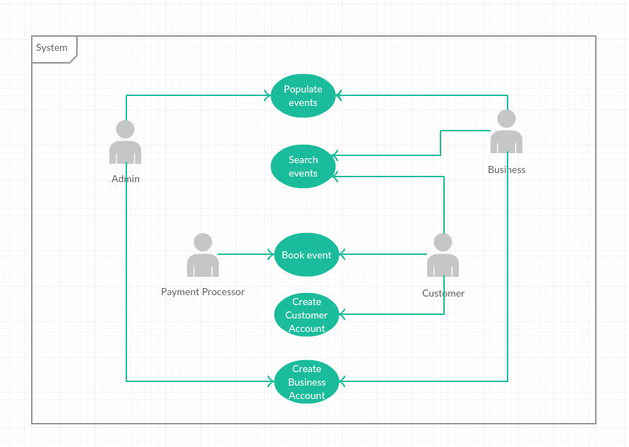

### Requirement 1: Populate Event

This is where a Business can add an Event so that users can select one.

#### Description & Priority

This is a vital part of the Web Application. These Events will be added by the Business so that a Customer can select them and book them. Without this requirement, the application would not work.

#### Use Case

Populate Event

**Scope**

The scope of this use case is to for a Business to create Events on the Web Application. When created, the Business can create a new Event or edit their own Events or view other public Events that have been previously added and approved.

**Description**

This use case describes how a Business can add an Event by inputting relevant data into text fields, or selecting the likes of a calendar and time drop-down menu. All new Events must be validated by an Admin (for likes of payment, profanity, etc.).

**Flow Description**

**Precondition**

* Admins must approve new events before they are live on the Web Application.
* Admins are always logged in
* Admins must check new Events for profanity, errors and misspellings and/or confirm changes with Business.
* Business have previously created an account.
* The communication between the Server/Internet and the Web Application must be connected (via mobile Wi-Fi).
* If required, the Server and Web Application need to have the latest updates.
* When an Event is “live”, this means that the event is public for the Customer.
* Many pages exist within the app
* A Database stores the events.

**Activation**

This use case starts when a Business wishes to sign in to their previously created account and create a new event.

**Main flow**

1. The System is currently in a wait state on the Main Page, waiting for a button to be tapped. The buttons are; “Log in/Sign up”, “Continue as Guest” and “Business Log in/Sign up”.
2. The Business selects “Business Log in/Sign up”.
3. The Business enters in their username and password.
4. System displays buttons “Create new event”, “Edit event” and “Search live events”
5. The Business selects “Create new event”.
6. System displays “New event page”. The page contains text boxes for the Business to input data.
7. The Business inputs the title.
8. The Business selects how many places are available. If left blank, it’s unlimited.
9. The Business inputs the Price of the Event.
10. The Business selects whether payment can be made at Event. (Yes/No)
11. The Business enters Price
12. The Business inputs the address.
13. The Business checks the Google Maps marker and edits it if necessary.
14. The Business inputs the phone number and/or email for event enquires.
15. The Business selects a date from a calendar.
16. The Business selects a time from a drop-down menu.
17. The Business selects whether Transport is included (Yes/No option)
18. <See A1>
19. The Business selects “No” option.
20. The Business selects Save. <See E1>
21. System sends data to Database on the server.
22. System displays message “Your Event has been received and will be checked by an admin before going live”.
23. The Business can log out or browse their own events or other public events.
24. Admin receives notification there’s a new event.
25. Admin checks event for profanity, spelling errors, etc.
26. Admin checks for payment from Business (outside System)
27. Admin approves Event provided there’s payment (outside system).
28. Event is live.

**Alternate flow**

A1 : Transport selection is “Yes”

12. The Business inputs Transport company.

13. The Business inputs pickup location and time.

14. The Business inputs drop-off location (if different from event)

15. The Business inputs return pickup location (if different from event) and time.

16. The Business inputs return drop off (if different from original pick up location).

17. <Returns to Step 13 in Main flow>

**Exceptional flow**

E1 : Network connection lost when Business is creating Event

1. The System is unable to connect to the Server or the Internet due to (e.g.) Server being upgraded.
2. The System saves the current page and the inputs from the Business.
3. The System send an email to Admin with error message.
4. Business is logged out by System.
5. Network connectivity returns.
6. Business logs back in.
7. System displays the page the Business was on.
8. <Returns to Step 12 in Main Flow>

**Termination**

This use case is terminated when the Admin has posted the Event.

**Post condition**

The system goes into a wait state and is ready for input, or for the Admin or Business to sign out of their account.

### Requirement 2: Search Events

#### Description & Priority

Search Events is where a Customer can search for events within the Web Application. This is a very important part of the Application, as without it, Customers would not be able to proceed to booking events.

#### Use Case

Search Events

**Scope**

The scope of this use case is allow Customers to search for events by searching via text and Google Maps. When the Customer selects an Event they wish to attend, the use case ends.

**Description**

This use case describes the how the Customer will input text and/or select a location from Google Maps. Nearby events will show on the map for the Customer to select.

**Flow Description**

**Precondition**

* The Customer is logged in
* Guest account is defined as a Customer. Guest accounts are given the username “Guest” followed by a random, unique number, e.g. Guest5256
* The network connectivity between the Web Application and the Server and/or Internet is connected.
* The user’s location is pre-set
* “Search page” is where the System shows the following buttons: “Search events” and “Your events”. Other buttons are present but not important for this Use Case.
* “Maps page” is where an embedded, interactive Google Maps map with markers or nearby events is shown along with a short list of the most popular apps.
* “Event page” is where information about an Event is shown for the Customer. It also contains “Return” and “Book” buttons.
* It is assumed that the Customer can only book one Event per booking or “transaction”.

**Activation**

This use case starts when a Customer taps “Search Events” within the Application.

**Main flow**

1. The System identifies that the Customer is logged in and that the network remains connected.
2. System displays buttons on “Search page”.
3. The Customer taps “Search events”.
4. The System changes page to “Maps page”. <See E1>
5. Customer selects an event from the list or select a marker on the map.
6. System shows Event Page.

<See A1>

1. Customer selects “Book”. Customer has successfully searched for an event

**Alternate flow**

A1 : Customer does not like Event, searches for another one.

1. The Customer selects “Return”

<Returns to Step 5 in Main Flow”

**Exceptional flow**

E1 : Google Maps server down

1. System displays message “Cannot connect to Google Maps”.
2. System removes Map and gives list of local towns/cities.
3. System keeps checking for Google Maps connection

<Returns to Step 5 in Main Flow>

**Termination**

When the Customer selects “Book”, this Use Case ends.

**Post condition**

The System waits for Customer input.

### Requirement 3: Book event

#### Description & Priority

Book Event is where a Customer books an Event. Depending on whether it’s free or not, the Customer may need to input their credit card information. This Use Case is not essential, but it would be very useful when implemented.

#### Use Case

Book Events

**Scope**

The scope of this use case allow Customers to book an event and go through the process of paying for it if requested.

**Description**

This use case describes the how the Customer will confirm a booking and input their credit card information if needed. It also describes how the communication between the credit card company and the System. A text/email confirmation message will be sent to the Customer on completion.

**Flow Description**

**Precondition**

* The Customer is logged in.
* Guest account is defined as a Customer. Guest accounts are given the username “Guest” followed by a random, unique number, e.g. Guest5256
* The network connectivity between the Web Application and the Server and/or Internet is connected.
* “Event page” is where information about an Event is shown for the Customer. It also contains “Return” and “Book” buttons.
* It is assumed that the Customer can only book one Event per booking or “transaction”.
* The Customer is on the Booking page and has previously searched for an event they would like.
* Payment Processor is the company/service that deals with actually accepting the payment.
* End Page is where the booking is complete. It lists the confirmed booking. The Customer can log out or review the booking.

**Activation**

This use case starts when a Customer taps “Book” on the Events Page.

**Main flow**

1. The System identifies that the Customer has tapped the “Book” button.
2. System shows Booking Page
3. System lists event and price.

<See A1 & A2>

1. Customer enters Credit Card information into respective fields.
2. Customer selects “Continue”.
3. System sends credit card information to Payment Processor

<See A3 & E1>

1. Payment Processor confirms payment.
2. System sends confirmation to Customer’s email or via SMS.
3. System shows End Page.
4. If no input from user within 60 seconds, the System logs the user out.

**Alternate flow**

A1 : Event is free.

1. System hides Credit Card information input boxes.

<Returns to Step 8 in Main Flow>

A2 : Business has selected that user can pay at the Event.

1. System displays message “Would you like to pay at the Event?”
2. If no -> Returns to Step 5 in Main Flow
3. If yes -> Returns to Step 8 in Main Flow

(Note, this would be hidden if Business does not allow Customers to pay at the Event)

A3 : Payment Processor declines card..

1. Payment Processor declines payment
2. System displays message: “Your payment has been declined”
3. Customer selects OK.

<Returns to Step 3 in Main Flow>

**Exceptional flow**

E1 : Payment Processor cannot be reached (e.g. Server down)

1. System displays message “Cannot process your payment. Please try again later.”

<Returns to Step 5 in Main Flow>

**Termination**

When the Customer logs out or is logged out by the System, this Use Case Ends.

**Post condition**

The System returns to the Main Page and waits for input.

### Requirement 4: Create Customer Account

#### Description & Priority

Customer account is where a Customer can create an account. It is not necessary for a Customer to create an account, but it is a useful tool.

#### Use Case

Create Customer Account

**Scope**

The scope of this use case allow Customers to create an account.

**Description**

This use case describes the how the Customer is able to create an account. If the Customer is a Guest, they can create an account from any page, e.g. Events Page, Booking Page, etc.

**Flow Description**

**Precondition**

* The network/Internet is connected.
* Create Customer Account page is a page where a Customer can input their information.

**Activation**

This use case stars when a Customer selects “Sign up” from the main page.

**Main flow**

<See A1>

1. Customer selects “Sign up” from the Main Page.
2. System displays “Create Customer Account” page.
3. Customer inputs their name (required)
4. Customer inputs their address, city
5. Customer inputs their email and/or phone number (one required)
6. Customer selects “Save”
7. System sends data to database.

<See E1>

1. System sends password and confirmation to Customer’s email and/or phone.

**Alternate flow**

A1 : Customer is a Guest and wishes to create an account from any page.

1. Customer selects “Sign up”.
2. System saves current page in current state.
3. System displays “Create Customer Account” page

<Returns to Step 3 in Main Flow>

1. System displays saved current page.
2. System deletes saved page from memory.

**Exceptional flow**

E1 : System cannot communicate with Database.

1. System displays message “Sorry, an error occurred!”
2. Customer clicks “OK”.
3. System returns to Main Page. (Account cannot be created)

**Termination**

When the Customer has created an account, this Use Case ends.

**Post condition**

The System waits for input.

### Requirement 5: Create Business Account

#### Description & Priority

Business account is where a Business can create an account. If a Business wishes to create an Event, a Business Account is required.

#### Use Case

Create Business Account

**Scope**

The Scope of this Use Case is to allow a Business to create an account, so that they can Create Events or Search live events.

**Description**

This use case describes the how the Business is able to create an account. All Business Account creations need to be approved by an Admin, for security and permission security.

**Flow Description**

**Precondition**

* The network/Internet is connected.
* Create Customer Account page is a page where a Customer can input their information.
* Admins must approve new Business Account
* Admins are always logged in
* A Business Account must be created from the Main Page and cannot be accessed when logged in as a Customer (or Guest)
* Business Sign Up Page is where a Business inputs their information. This is different from a Create Customer Account Page.

**Activation**

This use case stars when a Business selects “Business Sign Up”.

**Main flow**

1. Business selects “Business Sign Up”
2. Business inputs Company Name
3. Business inputs Representative’s name
4. Business inputs Representative’s email and/or phone number
5. Business selects Save

<See E1>

1. System sends data to Database.

<See A1>

1. Admin approves Business Account
2. System sends password and confirmation to Business’s email and/or phone.

**Alternate flow**

A1 : Admin does not approve Business Account.

1. Admin does not approve Business Account
2. System sends email/SMS to Business to inform that their Business Account was not created.

**Exceptional flow**

E1 : System cannot communicate with Database.

1. System displays message “Sorry, an error occurred!”
2. Business clicks “OK”.
3. System returns to Main Page. (Account cannot be created)

**Termination**

When the System sends communication to the Business, this Use Case Ends.

**Post condition**

The System returns to the Main Page and waits for input.